TASK 3: SQL Queries and Data Analysis Report

Objective:
The objective of this task is to perform SQL operations on the sales dataset using MySQL. The task includes retrieving records using SELECT statements, filtering data using WHERE clauses, sorting data using ORDER BY, grouping records using GROUP BY, and performing aggregate calculations using COUNT(), SUM(), and AVG() functions.

Database Creation
CREATE DATABASE SalesDB;
USE SalesDB;

Table Creation
CREATE TABLE Orders (
OrderID VARCHAR(20),
CustomerID VARCHAR(20),
Product VARCHAR(50),
Category VARCHAR(50),
Quantity INT,
Price DECIMAL(10,2),
TotalPrice DECIMAL(10,2),
OrderDate DATE,
OrderStatus VARCHAR(20)
);

Dataset Import
The dataset was imported into MySQL Workbench using the Import Wizard after converting the Excel file into CSV format.

SQL Queries Performed
1. Display All Records
SELECT * FROM Orders;

2. SELECT Query
SELECT OrderID, Product, TotalPrice
FROM Orders;

3. WHERE Clause
SELECT OrderID, Product, TotalPrice
FROM Orders
WHERE OrderStatus='Delivered';

4. ORDER BY Clause
SELECT OrderID, Product, TotalPrice
FROM Orders
ORDER BY TotalPrice DESC;

5. COUNT() Function
SELECT COUNT(*) AS Total_Orders
FROM Orders;

Output
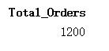
6. SUM() Function
SELECT SUM(TotalPrice) AS Total_Revenue
FROM Orders;
Output
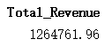

7. AVG() Function
SELECT AVG(TotalPrice) AS Average_Order_Value
FROM Orders;
Output
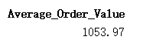

8. GROUP BY with COUNT()
SELECT Product,
COUNT(*) AS Number_of_Orders
FROM Orders
GROUP BY Product;
Output
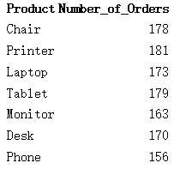
9. GROUP BY with SUM()
SELECT Product,
SUM(TotalPrice) AS Total_Sales
FROM Orders
GROUP BY Product
ORDER BY Total_Sales DESC;
Output
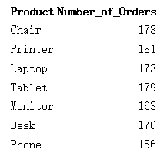

10. GROUP BY with AVG()
SELECT Product,
AVG(TotalPrice) AS Average_Sale
FROM Orders
GROUP BY Product;

Collectively,
A total of 1200 orders were present in the dataset.
The overall revenue generated was 1,264,761.96.
The average order value was 1,053.97.
Printer and Chair categories recorded the highest number of orders.
Chair generated the highest overall sales revenue among all products.
GROUP BY and aggregation functions provided meaningful insights into product-wise sales performance.

Conclusion
This task demonstrated the use of SQL for data retrieval, filtering, sorting, grouping, and aggregation. By applying SELECT, WHERE, ORDER BY, GROUP BY, COUNT(), SUM(), and AVG() functions, valuable business insights were extracted from the sales dataset. The analysis highlighted product performance, revenue generation, and order distribution, showcasing the importance of SQL in data analysis and decision-making.

